**Project 03 – Schedule (40pts)**

**Content Requirements (10pts)**

Using your entire 2nd semester class schedule, create a time table that follows the **exact** same format as the one pictured below.

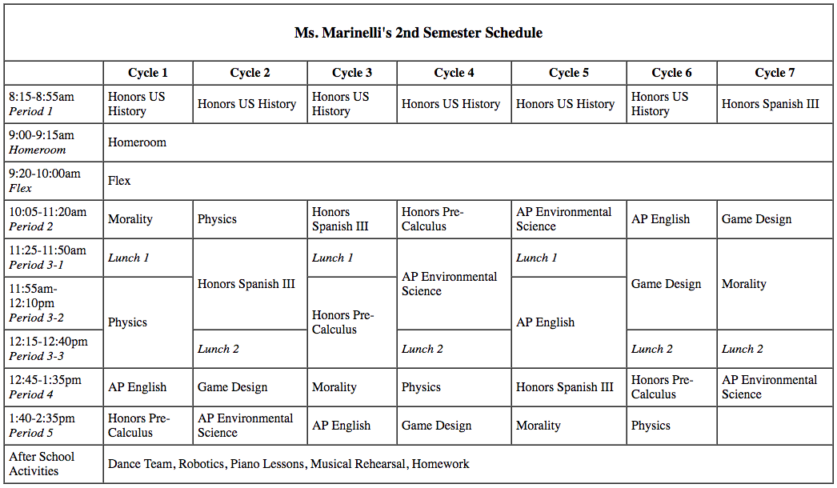

**Technical Requirements & Header Section (20pts)**

* Use the full HTML structure - <!DOCTYPE html>, <html>, <head>, <title>, <body>
* Match the formatting pictured above; use *italic* and **bold** tags as appropriate
* Merge cells to show homeroom and flex across all 7 cycles
* Merge cells to show if you have first or second lunch
* Because this is a larger table, be sure to use <thead>, <tbody> and <tfoot> to structure your HTML

**HINT!** To give your table a border, add this to your opening <table> tag: *<table border=”black”>*

**Commenting & Readability (10pts)**

* Use comments to put your name, the due date and program info at the top (under <!DOCTYPE html>)
* Have comments consistently throughout your HTML
* Correctly indent your code to make it easier to read
* Utilize whitespace to make your code easy to navigate

**Upload your assignment to GitHub and submit the link.**